THE UNIVERSITY OF AZAD JAMMU & KASHMIR, MUZAFFARABAD


COURSE TITLE | DSA
COURSE CODE | CS-2101
LAB TITLE | POINTERS
STUDENT NAME | HASEEB SHEIKH
STUDENT ROLL NUMBER | 2024-SE-31
INSTRUCTOR NAME | ENGR. SIDRA RAFIQUE
SUBMISSION DATE | OCTOBER 22, 2025

DEPARTMENT OF SOFTWARE ENGINEERING
DSA
Lab 2

Objective:
This lab aims to demonstrate basic traversing of the arrays using pointer Arithmetic.

Problem Statement:
Develop a C++ program that prompts a user to input five integer numbers. The program must then store these numbers sequentially in an array, calculate the total sum of the elements, and determine the largest (maximum) value present in the array. Finally, the program must display all the input numbers, the calculated sum, and the maximum value to the user.

Solution Approach:

Step | Process | Description
1 | Declaration | Declare int numbers[5], int sum = 0, int max.
2 | Input | Use a for loop (i = 0 to 4) to take 5 inputs via cin >> numbers[i];.
3 | Initialize Max | Set max = numbers[0]; after input collection.
4 | Processing (Sum & Max) | Use another for loop to: • Add each element to sum → sum += numbers[i]; • Check if numbers[i] > max → update max = numbers[i];
5 | Output | Display all numbers, the total sum, and the maximum value using cout.

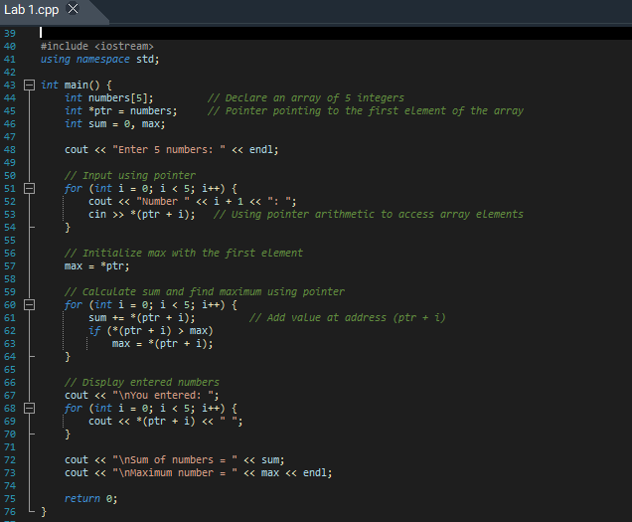
Program:

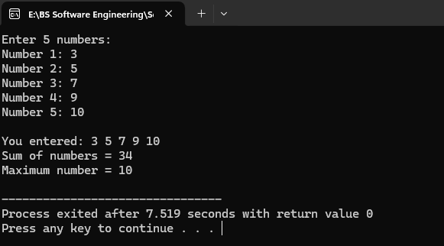
Output:

Explanation:
Code / Section | Explanation
#include <iostream> and using namespace std; | Enables input/output operations without using std:: prefix.
int numbers[5]; int *ptr = numbers; | Creates an array of 5 integers and a pointer pointing to its first element.
int sum = 0, max; | Initializes sum to 0 and declares max to store the largest number.
Input Loop (for i=0 to 4 → cin >> *(ptr + i)) | Takes 5 numbers from the user using pointer arithmetic.
max = *ptr; | Sets the first element as the initial maximum.
Processing Loop (for i=0 to 4) | Adds all numbers to sum and updates max if a larger number is found.
Display Loop (cout << *(ptr + i)) | Prints all entered numbers using the pointer.
Final Output | Displays the total sum and the maximum number.
return 0; | Ends the program successfully.

